Challenge Results Comparison Sheet

District Summary with all of the student data

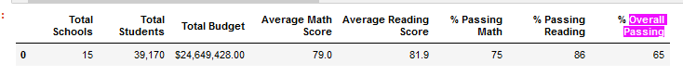

District Summary with Thomas High School 9th Grader’s NaN

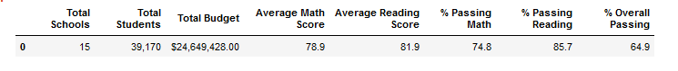

Per School Summary with all of the student data

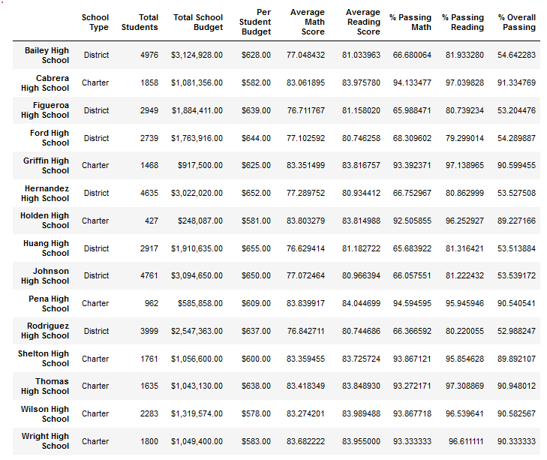

Per School Summary with Thomas High School 9th Graders NaN

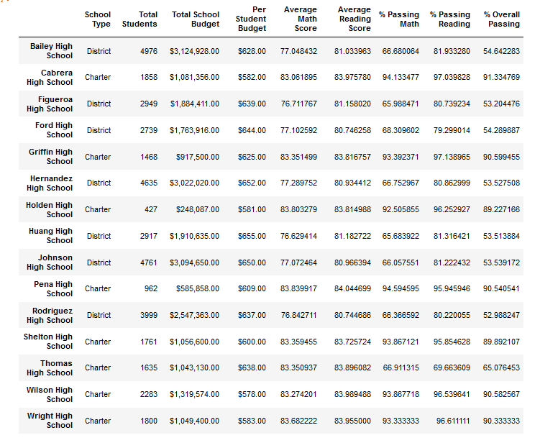

Highest Performing Schools, Thomas High School excluding 9th grade

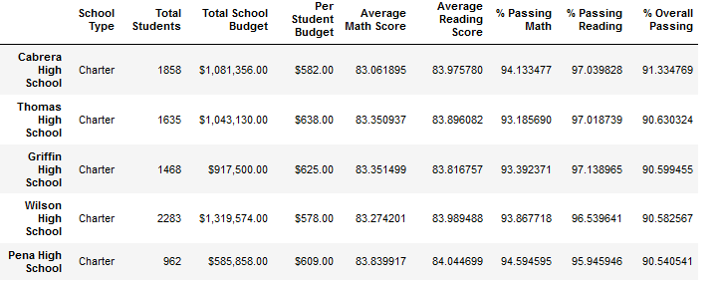

Highest Performing Schools, Thomas High School including 9th grade

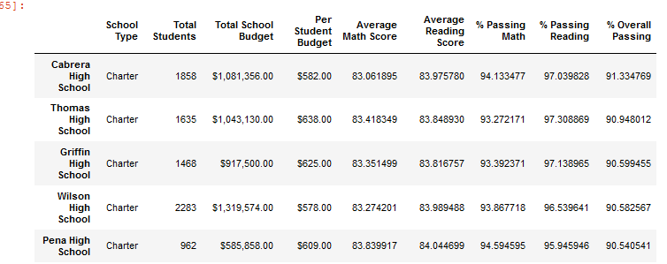

Lowest Performing Schools, Thomas High School excluding 9th grade

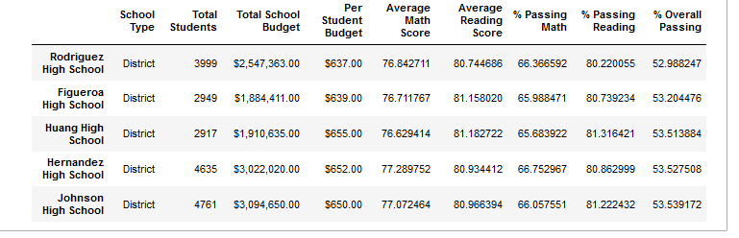Lowest Performing Schools, Thomas High School including 9th grade

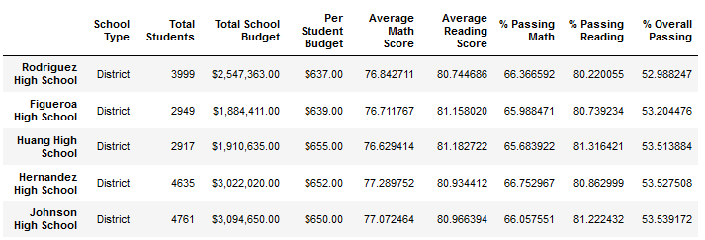

Math scores by grade, including the 9th grade Thomas

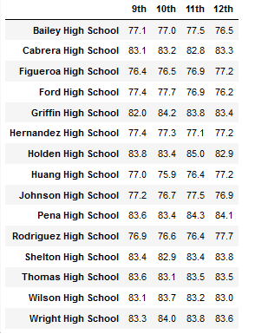

Math Scores by grade, excluding the 9th grade Thomas

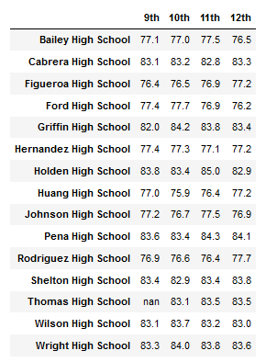

Reading scores by grade, including the 9th grade Thomas

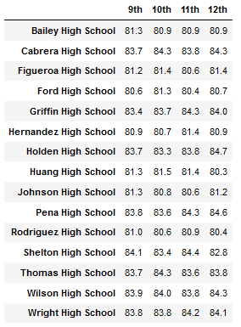

Reading Scores by grade, excluding the 9th grade Thomas

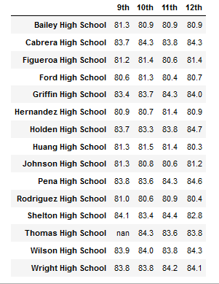

School Spending Bins excluding 9th grade Thomas

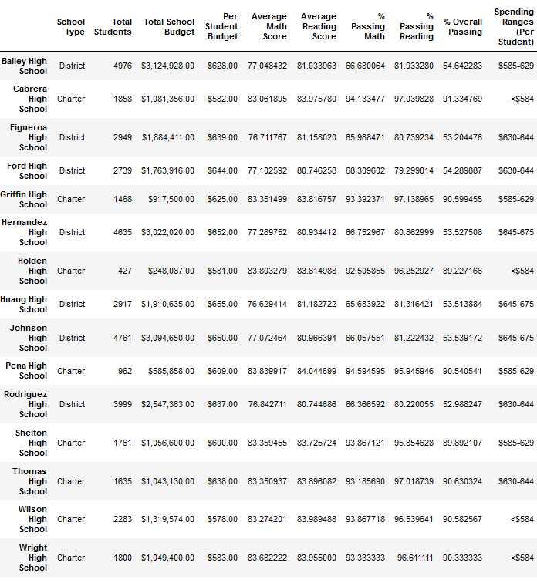

School Spending Bins including 9th grade Thomas (they should be the same)

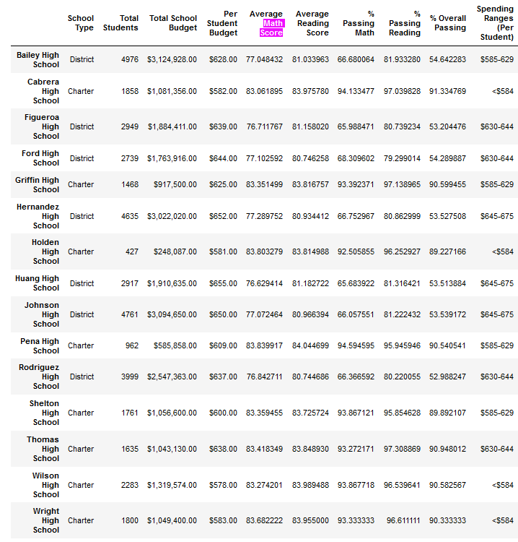

Spending Summary, excluding the 9th grade Thomas

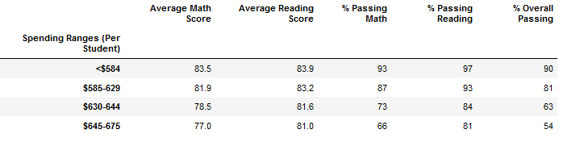

Spending Summary, including the 9th grade Thomas

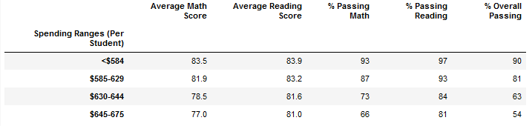

Scores by school size, excluding Thomas 9th grade

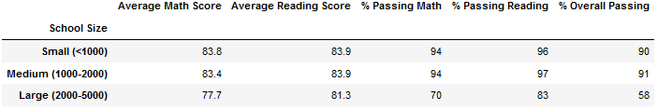

Scores by school size, including Thomas 9th grade

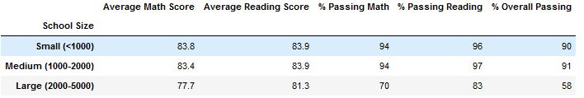

Scores by School Type, excluding Thomas 9th grade

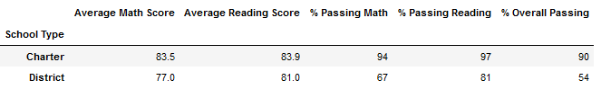

Scores by School Type, including Thomas 9th grade

